Week-8 GIT

GIT-HOL

Output
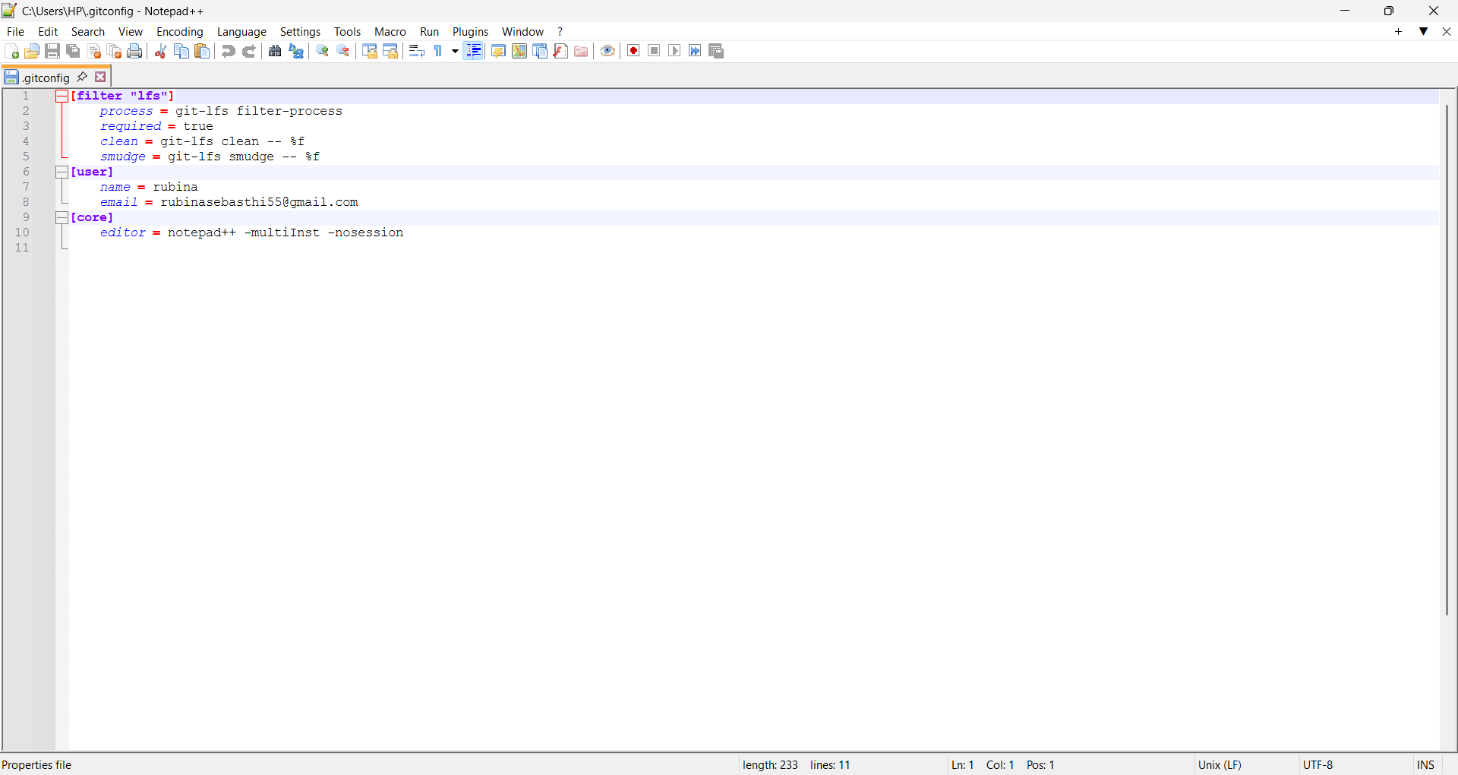

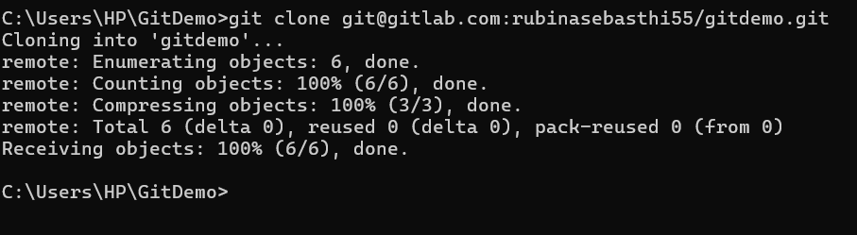

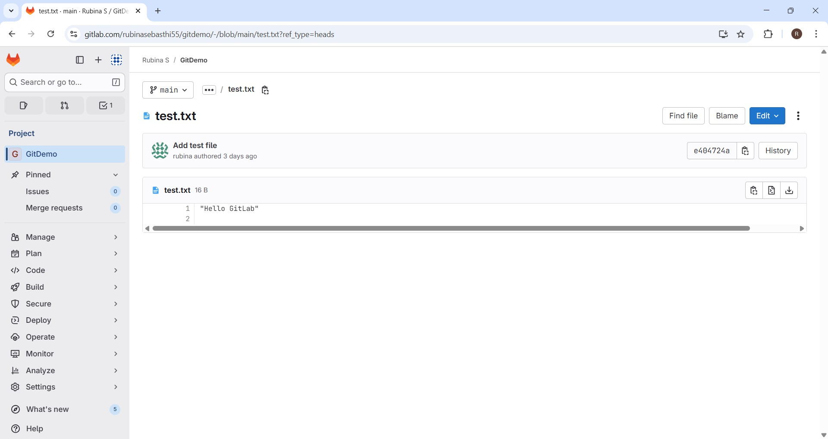

GIT-HOL

Objectives
  - Explain git ignore
  - Explain how to ignore unwanted files using git ignore
Answers

Explain .gitignore
- .gitignore is a configuration file in Git that specifies which files or directories should be ignored by Git (i.e., not tracked or committed).

- It helps keep the repository clean by excluding temporary, build, log, or system files that are not relevant to the project’s source code.

Explain how to ignore unwanted files using .gitignore
- Add file patterns (like *.log for log files or log/ for a folder) inside the
.gitignore file to tell Git to exclude them from tracking.

- Once added to .gitignore, these files will remain in your working directory but won’t appear in git status, won’t be staged, and won’t be committed to the repository.

Output
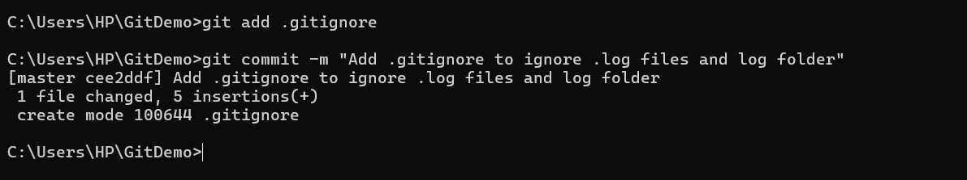
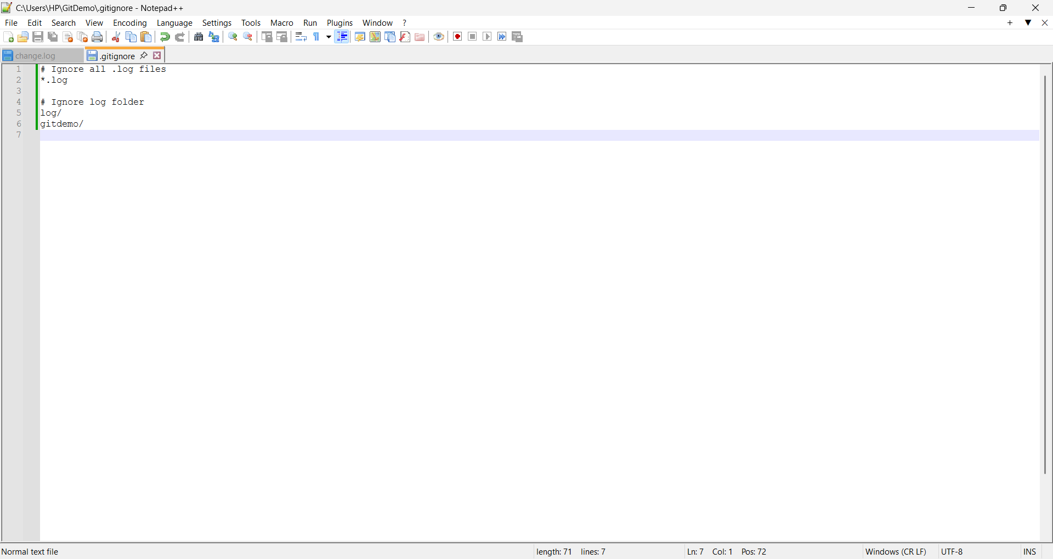

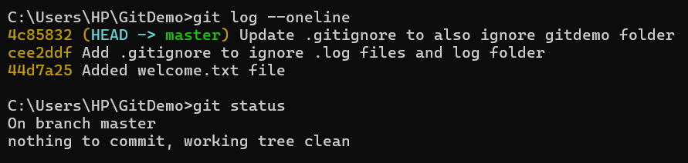

GIT-HOL

Objectives
  - Explain branching and merging
  - Explain about creating a branch request in GitLab
  - Explain about creating a merge request in GitLab
Answers

- Branching and Merging
  - Branching: In Git, branching allows developers to create separate lines of development to work on new features, bug fixes, or experiments without affecting the main project.

  - Merging: Once work in a branch is complete, merging combines the changes back into another branch (usually main or master) to integrate the updates.

- Creating a Branch Request in GitLab
  - A branch request is essentially creating a new branch in GitLab where you can push your changes before merging them into the main branch.

  - It helps in isolating development work and makes collaboration easier, as teammates can review and test changes independently.

- Creating a Merge Request in GitLab
  - A merge request (MR) in GitLab is used to propose merging changes from one branch into another (e.g., feature-branch → main).

  - It enables code review, discussion, and approval before the changes are merged, ensuring better collaboration and quality control.

Output
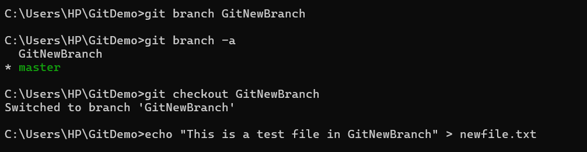
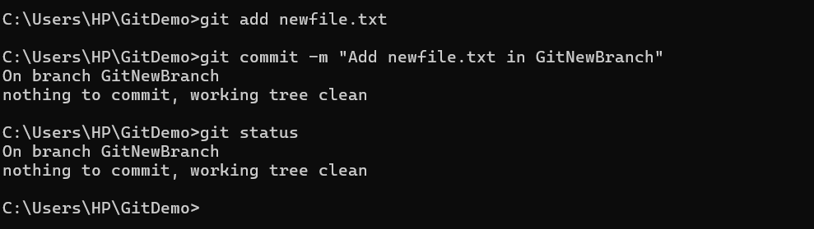

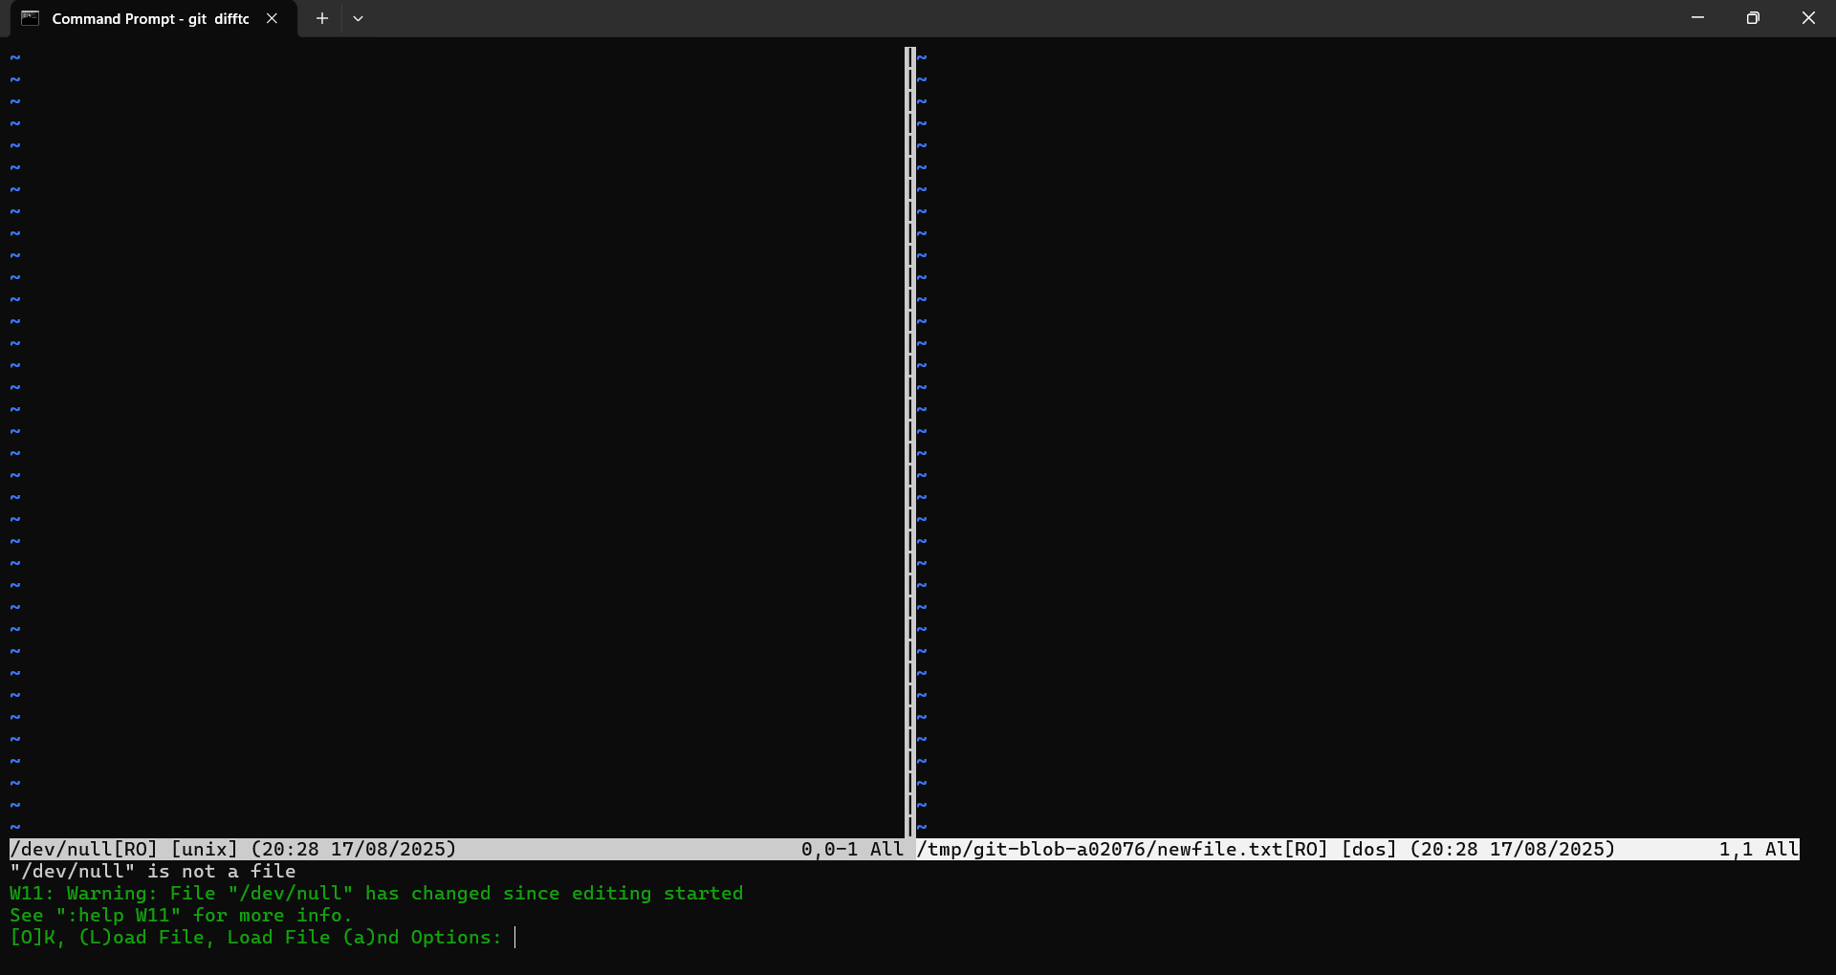
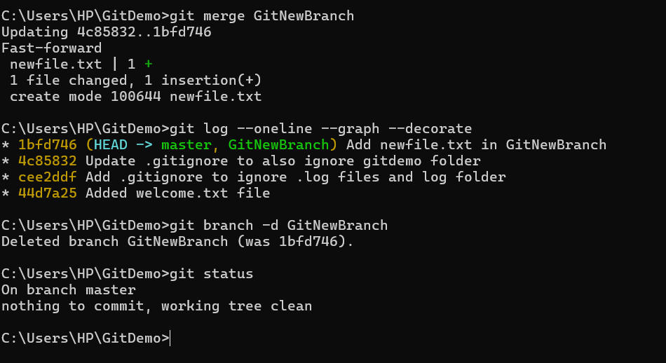

GIT-HOL

Objectives:
How to resolve the conflict during merge
- Identify and edit conflicted files:
When a merge conflict occurs, Git marks the conflict inside the file with
<<<<<<<, =======, and >>>>>>>. Open the file, review both versions, and manually edit it to keep the correct content.

- Mark conflict as resolved and commit:
After editing, run git add <file> to mark the conflict as resolved, then complete the process with git commit to finalize the merge.
Output
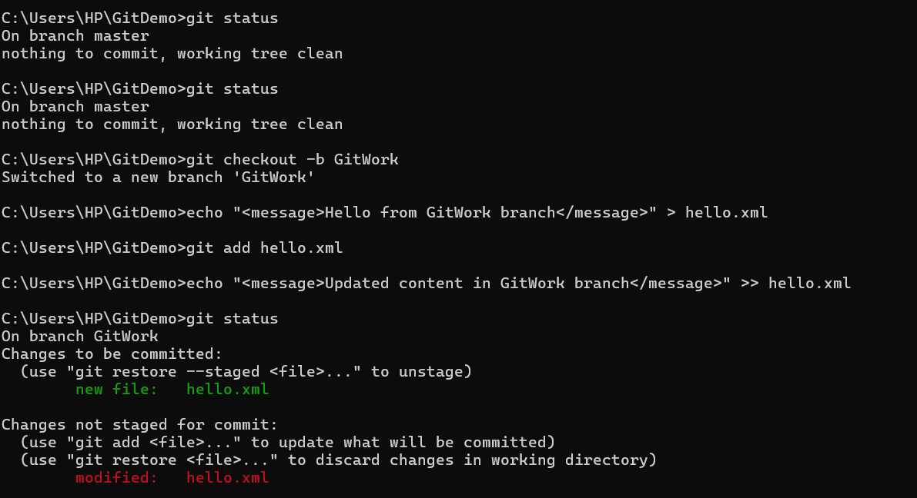

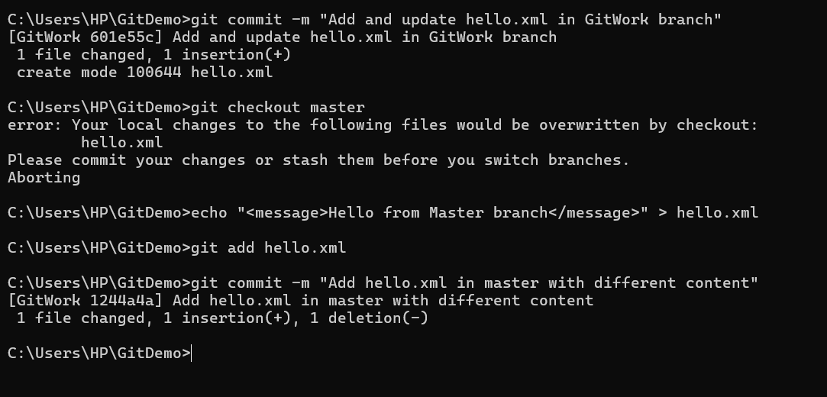
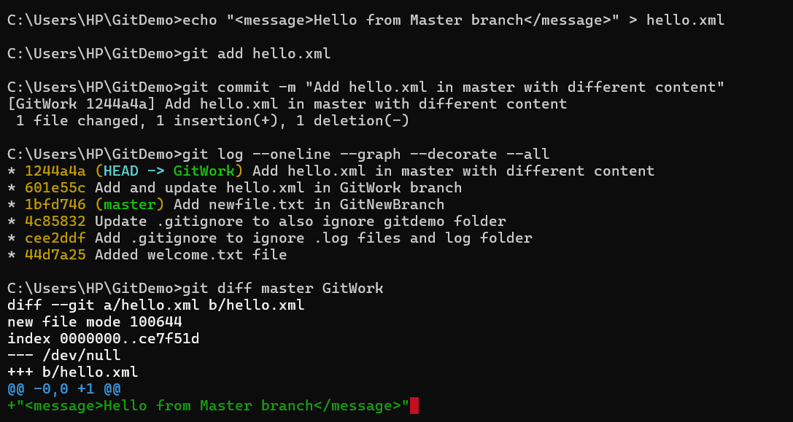

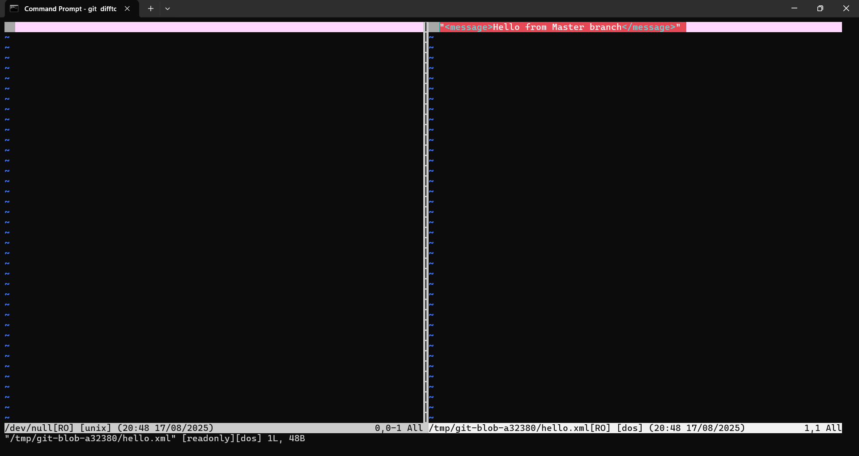
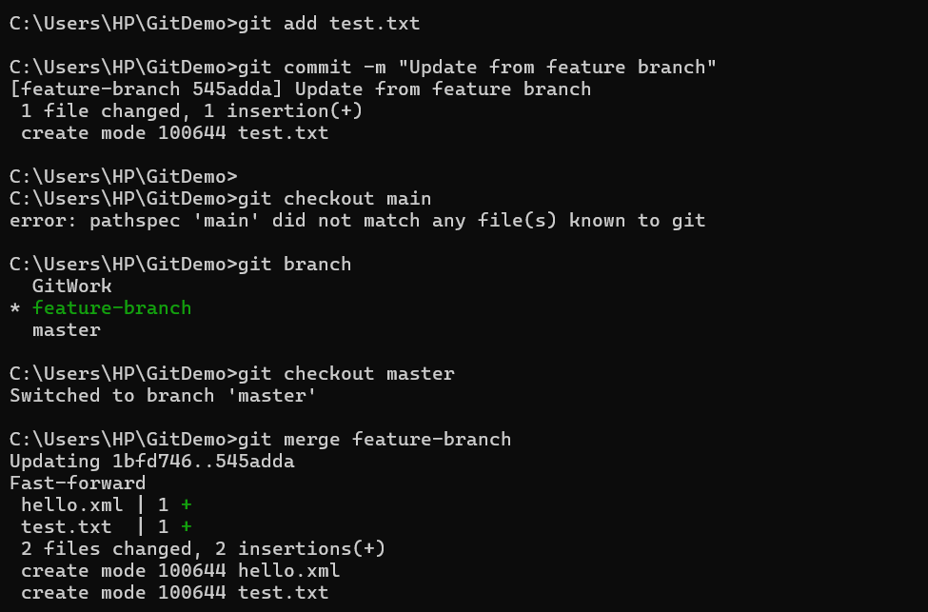

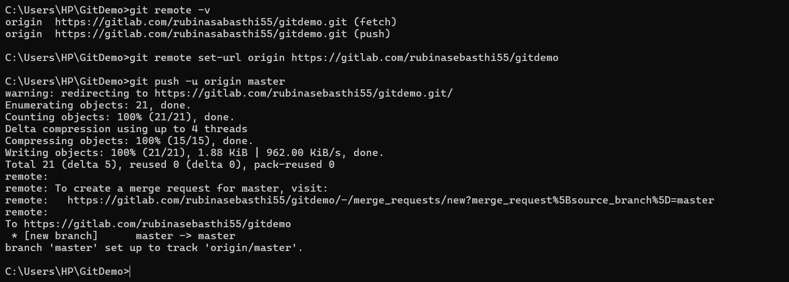

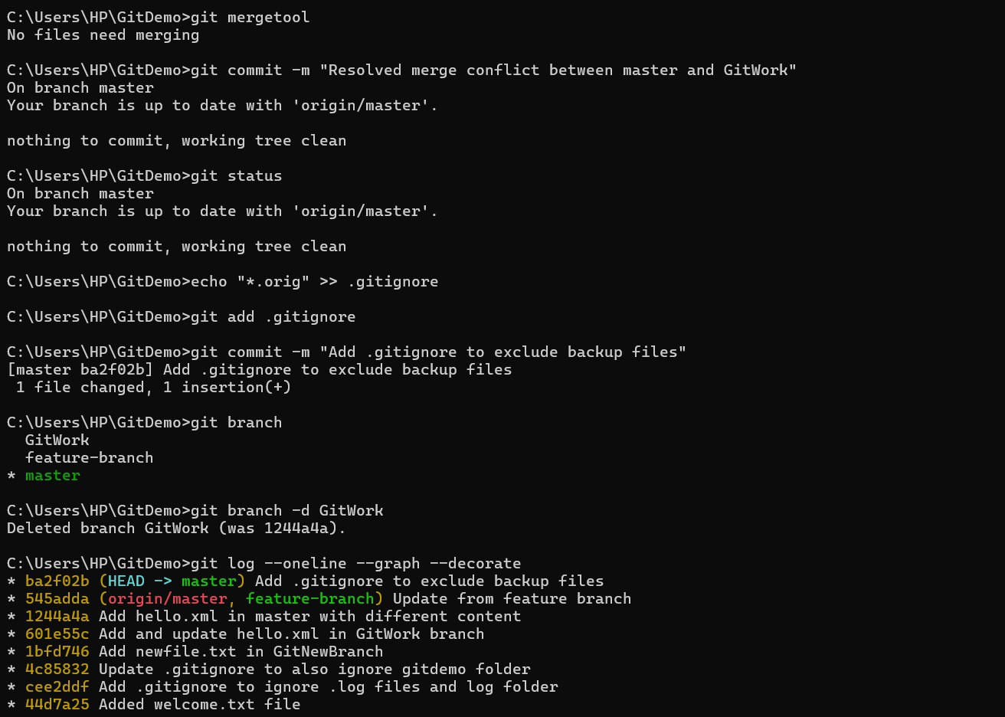

GIT-HOL
Objectives

- Explain how to clean up and push back to remote Git

Clean up local repository – Remove unnecessary branches, commits, or files (using git branch -d, git reset, or git clean) to keep the local repo organized and error-free.

Push changes to remote – Use git push (or git push origin <branch>) to sync cleaned-up changes back to the remote repository, ensuring both local and remote are in sync.

Output
